where
Papers written by Australian Maths Software

SEMESTER ONE

REVISION 3

MATHEMATICS METHODS
UNIT 3

2016

SOLUTIONS

SECTION ONE

1. (5 marks)
(a)
✓
✓
✓
(3)

✓
(1)

✓
(1)

2. (9 marks)
✓
(a) (i)
✓
✓
(3)
(ii)
✓
The acceleration is always constant as the velocity is linear
✓

and the acceleration is the gradient function of the velocity.
The gradient of the graph is always increasing so the
✓

acceleration is always positive. (3)
(b) Where there is a turning point in the displacement graph. ✓
As the acceleration graph is positive () at that point, ✓
the turning point in the displacement graph is a minimum. ✓ (3)

3. (8 marks)
(a) (i)
✓ ✓

(2)

(ii)
✓✓ -1/error

(2)
(b) ((i)
✓
✓
(2)

(2)
✓
✓
4. (6 marks)

(a) ✓ (1)
(b) (i) ✓✓ (1)

(ii) ✓ ✓
✓ (3)

5. (7 marks)
(a)
✓ ✓ (2)

✓
✓
✓
(3)

(c) (3)
✓ ✓

6. (7 marks)
(a) (i) ✓ (1)
(ii) ✓
At ✓ (2)

(b) (i) (2)
✓ ✓

(ii) ✓
At , ✓ (2)

7. (7 marks)
(a) ✓
✓ (2)

(b) ✓✓ (2)

(c)
✓
✓
✓
(3)

END OF SECTION ONE
SECTION TWO
8. (6 marks)
(a)
✓ ✓

(2)
(b) ✓
Changed direction when
✓

(2)
(c)
✓
✓ (2)

9. (9 marks)
(a) (i)
(1)
✓

(ii) ✓ (1)

(iii) E(X) = Σxp(x)
E(X) = 10 × + 20 × + 30 × + 40 ×
E(X) = 30 ✓

Var(X) = E(X²) – μ²
Var(X) =10² × + 20² × + 30² × + 40² × 30² ✓
Var(X) = 140 ✓
Sd(X) = ✓ (4)

(b) (i) ✓ (1)

(ii) E(X) = 5 ✓
Sd(X) = 1.75 ✓ (2)

10. (4 marks)
✓
✓
✓
✓

11. (8 marks)
(a) (2)
✓ ✓
(b) Maximum area when
✓
✓
✓

0 10
+ 0
✓

Therefore max at

✓
✓
Therefore the maximum area occurs when (6)
12. (7 marks)
(a) ✓✓✓✓-1/error (4)

(b)
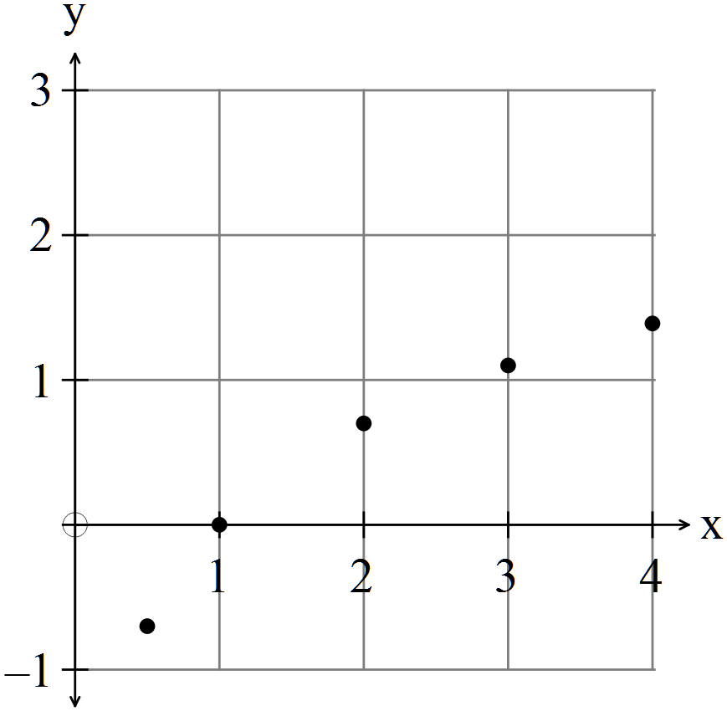 ✓✓
(2)
(c) ✓ (1)

13. (5 marks)
(a) ✓✓ (2)

(b) (i) ✓

✓
(2)

(iii) ✓ (1)

14. (14 marks
(a) (i) and ✓ ✓ (2)
(ii) Area = ✓✓ (2)
(iii) Area = 25.53 units² ✓✓ (2)

(b) (i) From below
✓
✓
(2)
(ii) From above
✓
(2)
✓
(iii) The area calculated from below is an underestimate.
The area calculated from above is overestimate.
The average combines both the underestimate and the overestimate
and should be more accurate. ✓
Average is 2.71875
Area ✓ (2)

(iv) ✓
Difference from estimate is ✓ (2)
15. (9 marks)
(a)
✓
As ✓ (2)

(b) ✓
✓
(2)
(c) At,
✓
✓
(2)
(d) so toy does not change direction.
At At
✓
✓
Therefore distance travelled is ✓ (3)
16. (8 marks)
(a)

In 2002 there will be 25 grams of DDT left so it will take 30 years. ✓ (1)

(b)
At ✓
✓ (2)

(c) ✓ (1)

(d) ✓ ✓ (2)
✓

(e) years ✓
✓ (2)

17. (8 marks)
(a)
 | 0 | 1 | 2 | 3 | 4
✓✓

(2)
(b) (2)
✓✓
(c) (i) ✓
✓
i.e. expect one family to have no boys. ✓ (3)

(ii) You cannot have a fraction of a family, so no, you would never get exactly that
number. ✓ (1)

18. (9 marks)

(a) 0.25 ✓✓ (2)
(b) ✓✓ (2)
(c) ✓✓ (2)
(d) ✓✓ (2)
(e) ✓ (1)
19. (8 marks)
(a)
 | 1 | 2 | 3 | 4
 | 0.1 | 0.2 | 0.4 | 0.3
✓✓
(2)
(b) (2)
✓ ✓
(c) Yes, as the relative proportions could be estimated. ✓ (2)

(d) By inspection, about 3. ✓✓ (2)
20. (6 marks)
(a)
Peter will have to guess 8 questions. ✓ (1)

(b) Needs to get 16 or more correct to get 80% ✓

Peter knows 12, so needs to get at least 4 more correct out of the 8 he has to guess. ✓

✓✓ (4)

END OF SECTION TWO

